S7 Representative RTK Scouting Examples
The following section presents examples of STADS system output and photographic evidence of cases where RTK-GNSS guided observations did not confirm deviance, confirmed positive deviance, and confirmed negative deviance.

Not Confirmed
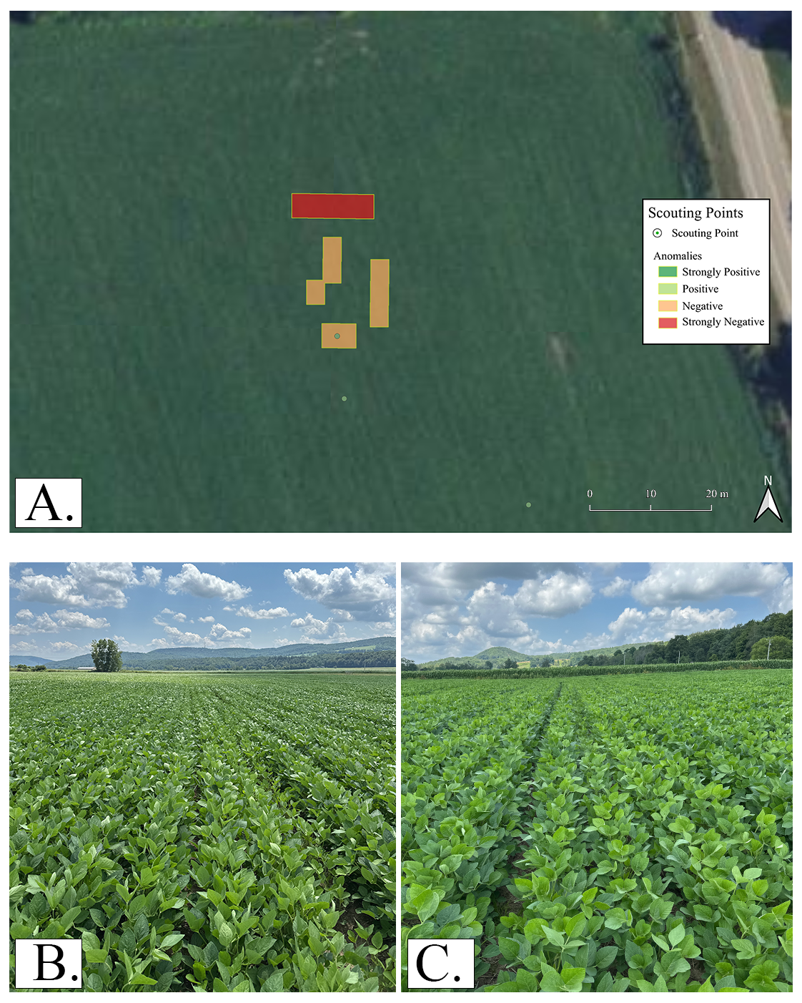
Fig. S7.1. Example of a STADS anomaly that was not confirmed by field scouting. Panel A shows the mapped STADS anomaly and paired scouting locations. Panel B shows field conditions at the scouting point located approximately 10 m inside the mapped anomaly, and Panel C shows field conditions at the paired comparison point located approximately 10 m outside the anomaly. Because no visually apparent difference in crop condition was observed between the inside-anomaly and outside-anomaly scouting locations, this case was classified as not confirmed..

Confirmed Positive Deviance
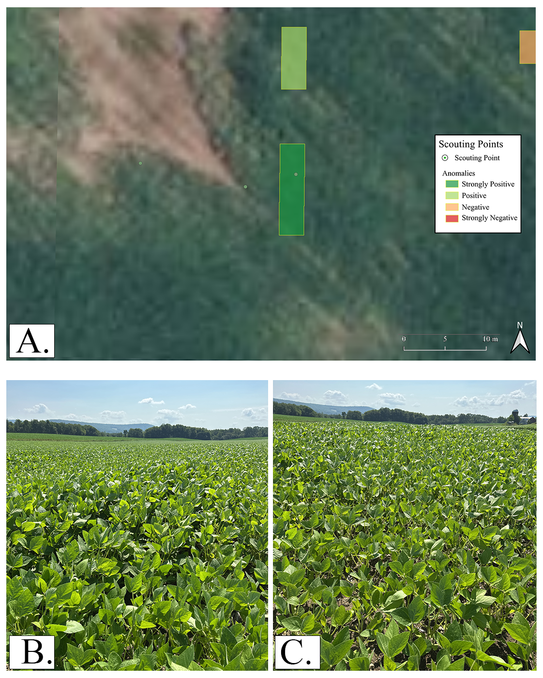
Fig. S7.2. Example of a STADS positive deviance anomaly that was confirmed by field scouting. Panel A shows the mapped STADS anomaly and paired scouting locations. Panel B shows field conditions at the scouting point located approximately 10 m inside the mapped anomaly, and Panel C shows field conditions at the paired comparison point located approximately 10 m outside the anomaly. Soybean plants within the anomaly exhibited greater vigor, increased canopy development, and higher canopy density than plants at the outside-anomaly comparison point. Accordingly, this case was classified as confirmed positive deviance.

Confirmed Negative Deviance
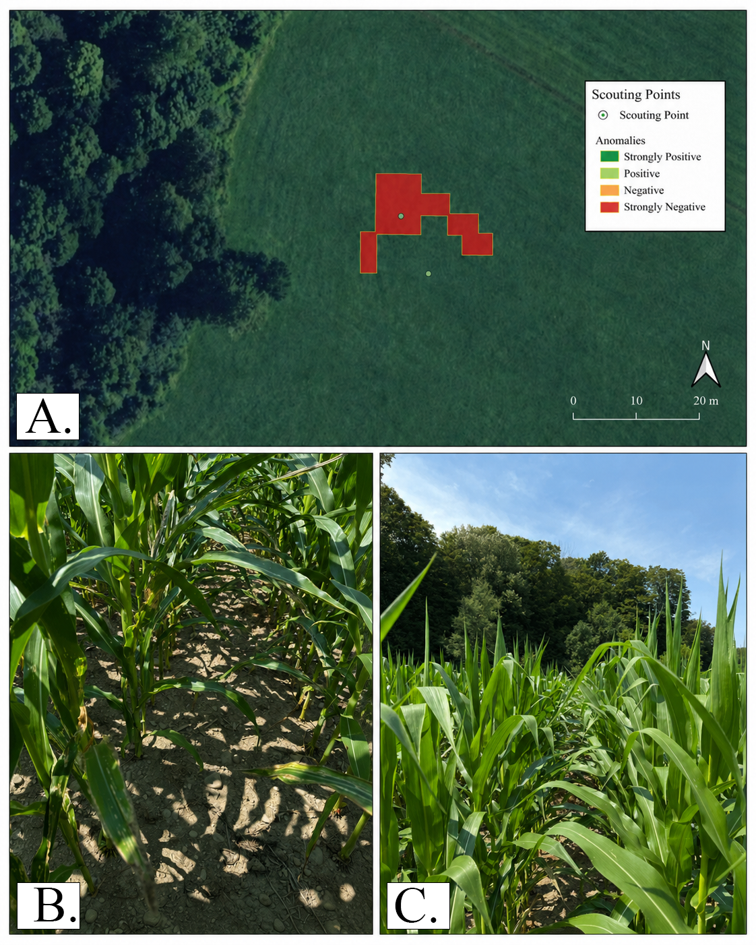
Fig. S7.3. Example of a STADS negative deviance anomaly that was confirmed by field scouting. Panel A shows the mapped STADS anomaly and paired scouting locations. Panel B shows field conditions at the scouting point located approximately 10 m inside the mapped anomaly, and Panel C shows field conditions at the paired comparison point located approximately 10 m outside the anomaly. Corn plants within the anomaly exhibited moderate disease pressure, reduced vigor, and lower canopy density than plants at the outside-anomaly comparison point. Accordingly, this case was classified as confirmed negative deviance.

